Risk Assessment
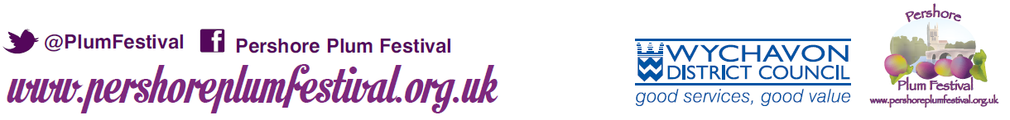

To ensure the festival complies with its insurance requirements, each individual stall holder must complete a Risk Assessment form, contained below.

You must complete this form to be considered for a pitch; otherwise your application form will be returned. “No Risk” is not acceptable.

To help you, we have included a few examples which you can use as your own, but please think carefully about any risks that may be associated directly to your stall/business.

Event: Pershore Plum Festival
Date: Monday 29 August 2022
Risk/Hazard | Those at risk | Controls / Actions
e.g. Vehicles & Stallholders in road during set-up and take down; Stability of gazebo and possible inclement weather; Trip hazard from table covers;  sharp objects on stall; Obstructions. | e.g. Stallholders, pedestrians, driver, children, event organisers | e.g. Awareness to those involved; leg weights affixed to each gazebo leg; table covers secured to the inside of table legs; no sharp objects placed near edge of table/near reach of children; front of stall to be kept clear at all times, boxes to be stored under tables.

