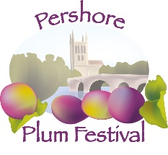
Theme of Competition
Market Gardening Heritage (Fruit and Vegetable Growing)

The theme ‘Market Gardening Heritage’ invites a celebration of the local area’s cultural history in fruit and vegetable growing. We want entrants to consider the history of this industry, the legacy of which still shapes the Vale of Evesham.
Between the 19th and mid-20th century, market gardening was an industry which sculpted the economy and lives of many living in the local area. The majority of the population of Evesham, Pershore and the surrounding areas were employed in market gardening. They grew a wide variety of vegetables, fruit, herbs and cut flowers to be sold at markets across the country.
The Market Gardening Heritage Project have collated an archive on the history of market gardening in the Vale of Evesham. As part of their work they have carried out a survey of surviving market gardening buildings, restored three as heritage sites, collected oral testimonies of local memories and held a programme of public events and displays.
We would like Art Competition entrants to use this project as inspiration, perhaps even getting out to visit the hovel sites themselves or speaking to their own relatives whose experiences of market gardening might inspire a creative response! You might be inspired by some of the historic photographs or wish to create a study of local produce and create your artwork in the style of a particular artist. You might have worked on the market gardens as a child and wish to express those memories through your artwork.
Please head to the Explore the Past website for access to archival resources which might provide inspiration.
www.explorethepast.co.uk/project/market-gardening-heritage
If you have any further questions, please email art@pershoreplumfestival.org.uk and we will be happy to help.

