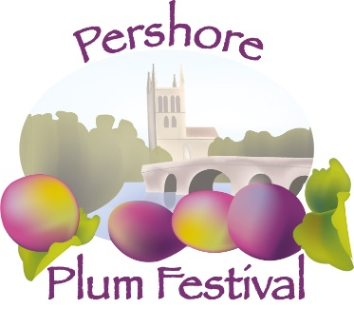
Pershore Abbey

CLASSIC CAR SHOW
August Bank Holiday Monday 31.8.2020
Site Access from 08.00
Single Car / Group Booking

Number of Cars
For multiple booking see overleaf
Model: | Reg. Number:
I enclose a cheque for £5 per car as a donation to Pershore Abbey
Payable to Pershore Abbey. BACS details available on request

Name: | Address:
Contact Number: | Email:
Please return your Application with Booking Fee to:
Pershore Abbey Classic Cars
11 Broad Street
Pershore WR10 1BB
Please include a Stamped Addressed Envelope for Show Pass
Show Pass will be required for Entry to the Car Show
For further Information  Tel: 07973464661 | Email: classiccars@pershoreabbey.org.uk
Cut off date for Booking is 31st July 2020
Thankyou for your application, we look forward to welcoming you

Car Register/Club/Group:…
Name | Model | Reg no. | Paid
DISCLAIMER
Car owners and all visitors to the car show are respectfully informed that the Plum Festival Organizer’s cannot accept responsibility or liability for theft, loss or injury on this site.
In the event of the show not going ahead due to adverse weather, no refund is payable.

